Carbon Black & Black Masterbatch
Carbon Black
Carbon black is a generic term for finely divided carbon. Carbon black is produced through the incomplete combustion of a petroleum feedstock. Under magnification, the composition of carbon black particles can be measured. The primary particles are measured in nanometers (mµ). The primary particles join through van der Waals forces to form tightly bound clusters called aggregrates. The size and shape of the aggregate defines the structure of the carbon black. A highly structured carbon black would be composed of many carbon black particles combined into a multi-branched aggregate. The aggregates loosely combine to form agglomerates.
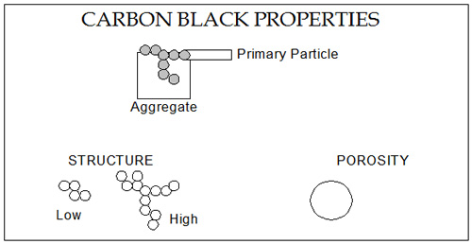
Particle size has a direct influence on performance properties. The particle sizes
with typical ranges of 14mµ – 90mµ are used in the plastics industry. The chart below demonstrates the influence of particle size on several critical indices.
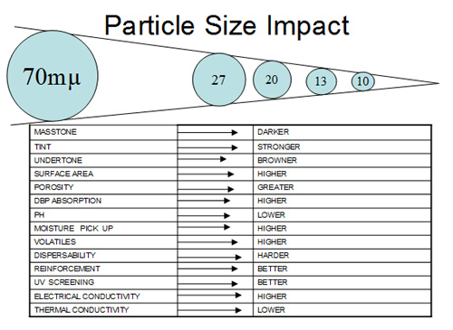
Black Masterbatch
Black concentrates are used not only for the coloration of plastics, but also to impart special properties such as conductivity and light stability. Ampacet has a vast array of black concentrates designed to meet your particular requirements.

